Oracle Database Administration Services

ORACLE Case Study for Diagnosing Database Slowness

Submitted to



By



CIS, Wipro Limited

Document Details

Project Name | RWE Npower
Account | CIS
IT Component/Application Title | ORACLE Case Study for Diagnosing Database Slowness
Current Version | 1.5
List of Contributors | Chetan Patel,Saurabh Nigam, JitenKumar Pansara,Sreya Puthukudy
Customer Contact Information

Version History
(All revisions made to this document must be listed in chronological order. All revisions must be approved. Review and Approval can be done by an internal source or by the customer)
Version | Date of Revision | Description | Author | Reviewed By | Approved By
1.0 | 16-05-2015 | Intial Draft | Chetan Patel | Chetan Patel | Mihir Gajjar
1.1 | 22-08-2016 | Document Completed | Chetan Patel | Saurabh Nigam | Mihir Gajjar
1.2 | 23-09-2016 | Updated document to standard format | JitenKumar Pansara | JitenKumar pansara | Mahesh Keshatwar
1.3 | 17-05-2017 | Wipro and Innogy Logo changed | Sreya Puthukudy | JitenKumar pansara | Mahesh Keshatwar
1.4 | 31-10-2017 | Updated document to Wipro Standard format with header and footer | Sreya Puthukudy | JitenKumar pansara | Mahesh Keshatwar
1.5 | 30-12-2018 | Updated the content | Sreya Puthukudy | JitenKumar pansara | Santosh Badiger

Document Distribution List
S.No | Name and Company | Purpose
1 | RWEIT-ORACLEDBA | This document is a Case Study for Diagnosing Database Slowness
2

TABLE OF CONTENT
1. Purpose 5
2. Scenario 5
3. Flowchart On Root Cause Analysis Of The Problem 6
4. Case Study Diagnosing Database Slowness 7
4.1 Users Complain Of Slowness 7
4.2 Login To Aix: 7
4.3 Execute The Topas Command 7
4.4 Check The Pid For The Process 9
4.5 Obtain The Corresponding Sid And Hash Value For The Pid 9
4.6 Determine The Text Of The Query Using Hash Value: 11
4.7 Generate Explain Plan For The Query 11
4.7.1 Using Explain Plan For Statement 11
4.7.2 Using Generic Scripts 11
4.8 Check The Cost 13
5. Note: 15
5.1 Nmon Tool 15
5.2 Reference To Reduce High Buffer_Gets: 16
5.3 Reference To Remove Database Locks: 16
5.4 Reference To Check High Intensive Queries 16
5.5 Reference To Different Ways To Generate Explains Plan And Cost: 16
6. References And Links 17

Purpose
This Document Is Prepared For the Management And Troubleshooting Of Oracle Database Administration Services at RWE GBS UK.

Scenario
Dear Database Administrators, there are times when each of us have to face some situations that are not very pleasant. Facing an irate client/customer is one such situation. All the irate customer/caller/user needs is some reassurance and quick answers and we fail exactly here – in maintaining calm, not panicking and being alive to the situation. This comes from understanding why the caller/user/customer is irate in the first place
Here are some questions that you can use in handling such situation if you ever face one. Find out

- What is it that is expected out of you (find out what are the 1 to 5 things that you have to do)
- Try and give the user/caller/customer some quick answers. Remember, letting people know why something happened gives them confidence that you are well aware of the situation. (eg: why is a database getting slow?)
- Ask yourself, where do you start and how to probe in finding out the root cause.
- Ask yourself what path /procedure will be the best one to adopt in finding out a solution for the issue”

Find the answer to these questions in the below document.

Flowchart On Root Cause Analysis Of The Problem
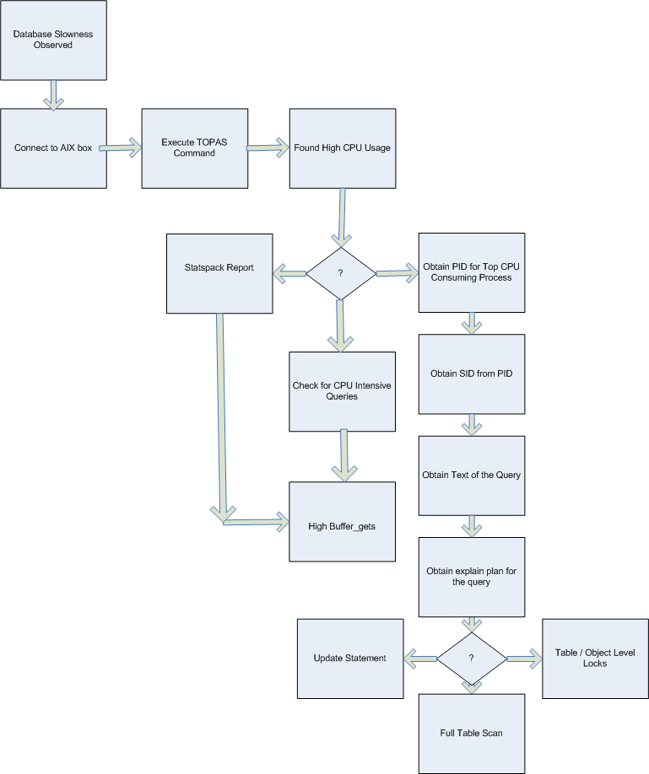

Case Study Diagnosing Database Slowness

Users complain of slowness
Users complain of slowness.

Login to AIX:
Connext to AIX box using putty.
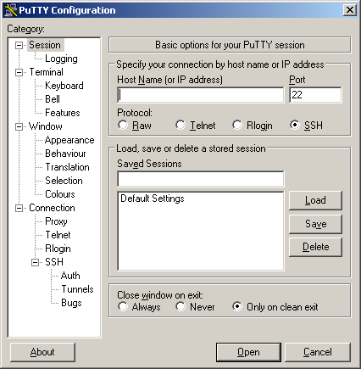

Execute the topas command
Execute the topas command to obtain the CPU idleness. Execute the Topas command for AIX and top in rest of platforms viz. solaris, linux, etc.
For more analysis, we can execute nmon command. See Note for detailed document on nmon.
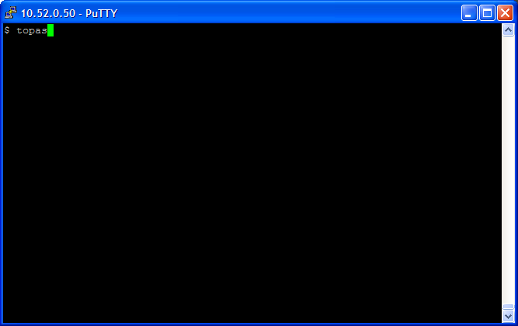

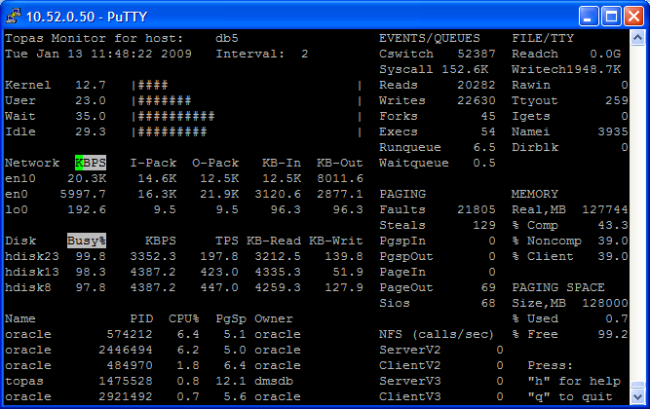

Here the CPU idleness is 29.3. This value is observed to be less than the optimal value which is 10%.

Check the PID for the process
Now check for the PID of the process with high CPU consumption.

Obtain the corresponding SID And Hash Value for the PID
Execute the below query and provide the PID, observed above as input.

select S1.sid ,s1.serial#,s1.status,s1.SQL_HASH_VALUE,s2.sql_text from v$process p,v$session s1,v$sqlarea s2
where p.addr = s1.paddr and s1.SQL_HASH_VALUE = s2.HASH_VALUE
and p.spid=&spid;

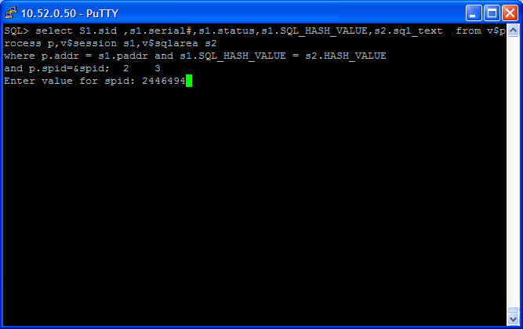

The output of the query as follows:

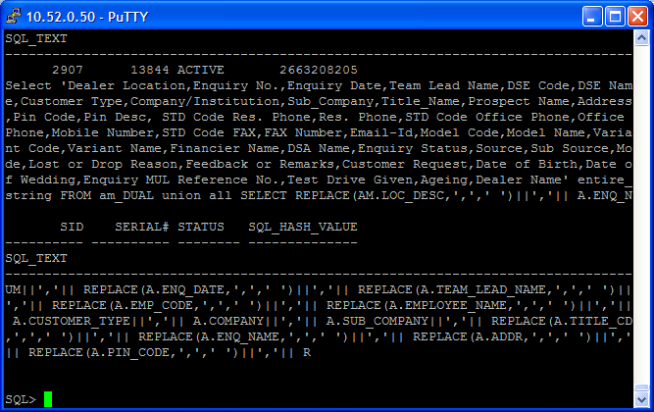

Determine the text of the query using hash value:

SQL> select sql_text from stats$sqltext where hash_value in ('&hash') order by hash_value, piece;
Enter value for hash: 2301379024
old 1: select sql_text from stats$sqltext where hash_value in ('&hash') order by hash_value, piece
new 1: select sql_text from stats$sqltext where hash_value in ('2301379024') order by hash_value, piece

SQL_TEXT
----------------------------------------------------------------
SELECT BIN_LOC FROM PM_STOCK_BIN_LOC WHERE PARENT_GROUP = :B6 AN
D DEALER_MAP_CD = :B5 AND LOC_CD = :B4 AND STORES_CD = :B3 AND P
ART_NUM = :B2 AND COMP_FA = NVL (:B1 , COMP_FA)

Generate explain plan for the query

4.7.1 Using EXPLAIN PLAN FOR statement
SQL> explain plan for
2 SELECT BIN_LOC FROM PM_STOCK_BIN_LOC WHERE PARENT_GROUP = :B6 AND DEALER_MAP_CD = :B5 AND LOC_CD = :B4 AND STORES_CD = :B3 AND PART_NUM = :B2 AND COMP_FA = NVL (:B1 , COMP_FA);

Explained.

4.7.2 Using generic scripts
REM
REM explain.sql
REM

SET VERIFY OFF
SET PAGESIZE 100

ACCEPT hash_val CHAR PROMPT "Enter HASH_VALUE of the SQL : "

select module,sql_text,FIRST_LOAD_TIME from v$sqlarea where HASH_VALUE='&hash_val';

COL id FORMAT 999
COL parent_id FORMAT 999 HEADING "PARENT"
COL operation FORMAT a35 TRUNCATE
COL object_name FORMAT a30

SELECT distinct id, parent_id, LPAD (' ', LEVEL - 1) || operation || ' ' ||
options operation, object_name
FROM v$sql_plan
WHERE HASH_VALUE = '&hash_val'
START WITH id = 0
AND HASH_VALUE = '&hash_val'
CONNECT BY PRIOR
id = parent_id
AND HASH_VALUE = '&hash_val'
order by id;

Saved the above script as explain9i.sql:

@?/explain9i.sql
Enter HASH_VALUE of the SQL: 2301379024

MODULE
----------------------------------------------------------------
SQL_TEXT
-----------------------------------------------------------------------
FIRST_LOAD_TIME
-------------------
sqlplus.exe
SELECT BIN_LOC FROM PM_STOCK_BIN_LOC WHERE PARENT_GROUP = :B6 AND DEALER_MAP_CD = :B5 AND LOC_CD = :B4 AND STORES_CD = :B3 AND PART_NUM = :B2 AND COMP_FA = NVL (:B1 , COMP_FA)
2009-01-13/08:36:35

ID PARENT OPERATION OBJECT_NAME
---- ------ ----------------------------------- -----------------------
0 LOAD AS SELECT
1 VIEW
2 FILTER
3 0 HASH JOIN PM_STOCK_BIN_LOC
4 0 TABLE ACCESS FULL PM_STOCK_BIN_LOC
5 0 TABLE ACCESS FULL PM_STOCK_BIN_LOC
6 1 TABLE ACCESS BY INDEX ROWID
7 1 INDEX UNIQUE SCAN
8 0 NESTED LOOPS PM_STOCK_BIN_LOC
9 1 INDEX RANGE SCAN
10 0 FIXED TABLE FULL PM_STOCK_BIN_LOC
11 0 FIXED TABLE FULL PM_STOCK_BIN_LOC
12 0 FIXED TABLE FULL PM_STOCK_BIN_LOC
13 0 FIXED TABLE FULL PM_STOCK_BIN_LOC
14 0 FIXED TABLE FULL PM_STOCK_BIN_LOC
15 0 FIXED TABLE FULL PM_STOCK_BIN_LOC
16 0 FIXED TABLE FULL PM_STOCK_BIN_LOC
17 0 FIXED TABLE FULL PM_STOCK_BIN_LOC
18 0 FIXED TABLE FULL PM_STOCK_BIN_LOC
19 0 FIXED TABLE FULL PM_STOCK_BIN_LOC
20 0 FIXED TABLE FULL PM_STOCK_BIN_LOC
21 0 FIXED TABLE FULL PM_STOCK_BIN_LOC
22 0 FIXED TABLE FULL PM_STOCK_BIN_LOC
23 0 FIXED TABLE FULL PM_STOCK_BIN_LOC
24 0 FIXED TABLE FULL PM_STOCK_BIN_LOC
25 0 FIXED TABLE FULL PM_STOCK_BIN_LOC
26 0 FIXED TABLE FULL PM_STOCK_BIN_LOC
27 0 FIXED TABLE FULL PM_STOCK_BIN_LOC
28 0 FIXED TABLE FULL PM_STOCK_BIN_LOC
29 0 FIXED TABLE FULL PM_STOCK_BIN_LOC
30 0 FIXED TABLE FULL PM_STOCK_BIN_LOC

For exploring different ways to generate the explain plan and cost refer note

Check the cost
SQL> @?/rdbms/admin/utlxplan
--------------------------------------------------------------------------------
| Operation | PHV/Object Name | Rows | Bytes| Cost |
--------------------------------------------------------------
|LOAD AS SELECT | | | | |
| VIEW | | 1K| 216K| 44 |
| FILTER | | | | |
| HASH JOIN | | 1K| 151K| 38 |
| TABLE ACCESS FULL |USER$ | 29 | 464 | 2 |
| TABLE ACCESS FULL |OBJ$ | 3K| 249K| 35 |
| TABLE ACCESS BY INDEX ROWID |IND$ | 1 | 7 | 2 |
| INDEX UNIQUE SCAN |I_IND1 | 1 | | 1 |
| NESTED LOOPS | | 5 | 115 | 16 |
| INDEX RANGE SCAN |I_OBJAUTH1 | 1 | 10 | 2 |
| FIXED TABLE FULL |X$KZSRO | 5 | 65 | 14 |
| FIXED TABLE FULL |X$KZSPR | 1 | 26 | 14 |
| FIXED TABLE FULL |X$KZSPR | 1 | 26 | 14 |
| FIXED TABLE FULL |X$KZSPR | 1 | 26 | 14 |
| FIXED TABLE FULL |X$KZSPR | 1 | 26 | 14 |
| FIXED TABLE FULL |X$KZSPR | 1 | 26 | 14 |
| FIXED TABLE FULL |X$KZSPR | 1 | 26 | 14 |
| FIXED TABLE FULL |X$KZSPR | 1 | 26 | 14 |
| FIXED TABLE FULL |X$KZSPR | 1 | 26 | 14 |
| FIXED TABLE FULL |X$KZSPR | 1 | 26 | 14 |
| FIXED TABLE FULL |X$KZSPR | 1 | 26 | 14 |
| FIXED TABLE FULL |X$KZSPR | 1 | 26 | 14 |
| FIXED TABLE FULL |X$KZSPR | 1 | 26 | 14 |
| FIXED TABLE FULL |X$KZSPR | 1 | 26 | 14 |
| FIXED TABLE FULL |X$KZSPR | 1 | 26 | 14 |
| FIXED TABLE FULL |X$KZSPR | 1 | 26 | 14 |
| FIXED TABLE FULL |X$KZSPR | 1 | 26 | 14 |
| FIXED TABLE FULL |X$KZSPR | 1 | 26 | 14 |
| FIXED TABLE FULL |X$KZSPR | 1 | 26 | 14 |
| FIXED TABLE FULL |X$KZSPR | 1 | 26 | 14 |
| FIXED TABLE FULL |X$KZSPR | 1 | 26 | 14 |

Since the cost is too high, check for proper index redesigning and reducing usage of bind variables.

SET VERIFY OFF
SET PAGESIZE 100

ACCEPT hash_val CHAR PROMPT "Enter HASH_VALUE of the SQL : "

SQL> select module,sql_text,FIRST_LOAD_TIME from v$sqlarea where HASH_VALUE=1556000858;

MODULE
----------------------------------------------------------------
SQL_TEXT
-----------------------------------------------------------------------
FIRST_LOAD_TIME
-------------------
sqlplus.exe
insert into test select * from test
2009-01-31/21:23:26

COL id FORMAT 999
COL parent_id FORMAT 999 HEADING "PARENT"
COL operation FORMAT a35 TRUNCATE
COL object_name FORMAT a30

SQL> SELECT distinct id, parent_id, LPAD (' ', LEVEL - 1) || operation || ' '
||
2 options operation, object_name
3 FROM v$sql_plan
4 WHERE HASH_VALUE = 1556000858
5 START WITH id = 0
6 AND HASH_VALUE = 1556000858
7 CONNECT BY PRIOR
8 id = parent_id
9 AND HASH_VALUE = 1556000858
10 order by id;

ID PARENT OPERATION OBJECT_NAME
---- ------ ----------------------------------- -----------------------
0 INSERT STATEMENT
1 0 TABLE ACCESS FULL TEST

Note:

NMON Tool
In step 1, we can execute nmon command for better analysis.
Please find the document on nmon attached below.


Reference to reduce high buffer_gets:
For High Buffer_gets, refer the below document:
Case Study: Reducing Buffer_gets

Reference to remove database locks:
For Database Locks, refer the below document:

Case Study: Removing Database Locks

Reference to Check High Intensive Queries
For checking High intensive queries, refer the below document:

Check for High Intensive Queries.doc

Reference to Different ways to generate explains plan and cost:
For exploring ways to generate explain plan and cost, refer the below document:
Generating SQL Explain Plan and Cost.doc

References And Links
http://download.oracle.com/docs/cd/B10500_01/server.920/a96533/ex_plan.htm
http://ucg.tomshardware.com/ucg/commands/topas-9873.html

